**HOSTING A WEBPAGE BY USING JENKINS JOB**

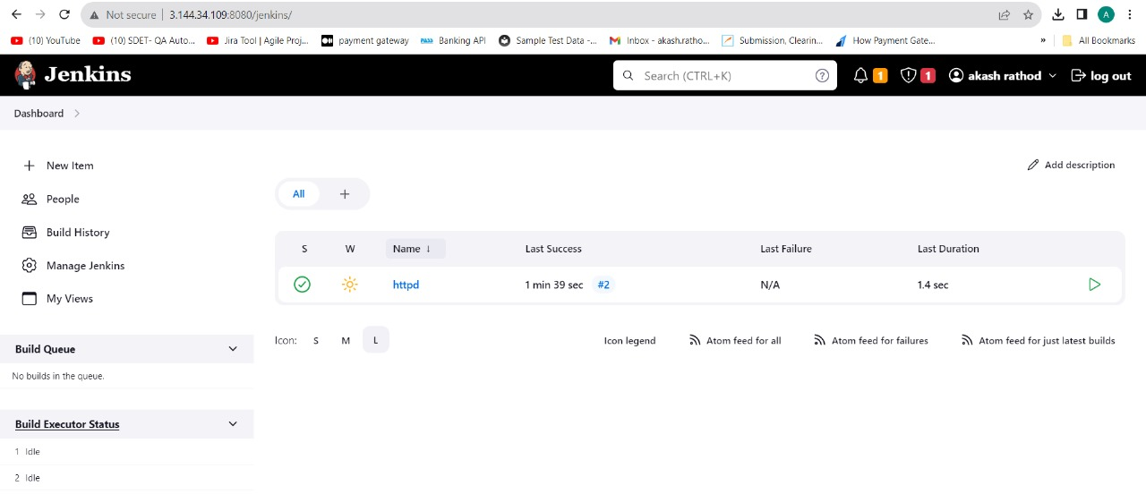

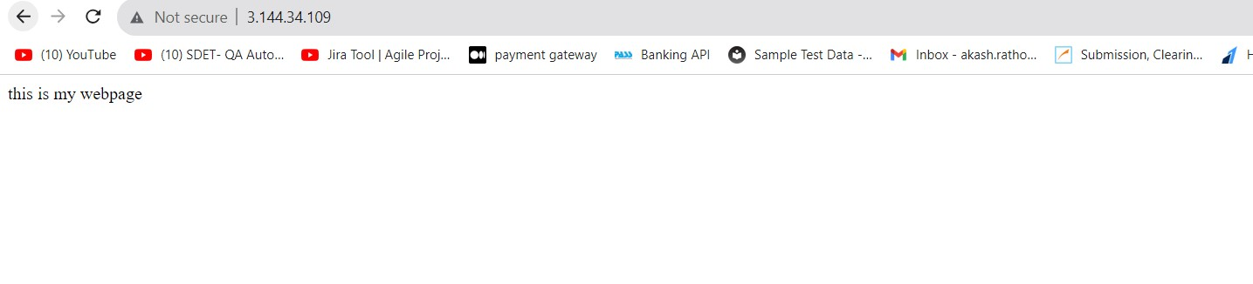

* Launch an instance and connect to it
* Install java-11-amazon-corretto.x86_64
* create a directory named servers
* Install and unzip tomcat 9 server
* Give 777 permissions to tomcat directory
* Go to webapps and download Jenkins.war from Jenkins io website
* Go to bin and start the server
* Check ip:8080/Jenkins
* Copy given command from Jenkins page and get the administrator password by using cat and paste that copied command.
* Copy password and paste in Jenkins page where password is required
* Install suggested plugins
* Log in into Jenkins
* Create a freestyle job
* Add description
* Select build setup as execute shell
* Enter the commands to host webpage by running these shell script on Jenkins.
* Commands

1. yum install httpd -y
2. service httpd start
3. chkconfig httpd on
4. echo "this is my webpage" > /var/www/html/index.html
5. cd /
6. chmod -R 777 var

* save and apply
* build the job
* check the webpage